Category: Hard

Competition: CSI KJSCE Code Wars 2017-18. Try it in the competition environment:

<https://www.hackerrank.com/contests/codewars2-round1/challenges/forest-survey>

Question:

The government of India instructed the forest rangers to survey their forests like the Sundarbans for the ecosystem health. These rangers were instructed to take at least 5 samples from each continuous area having a unique combination of species. Earlier surveys had plotted the the territories of each specie as a unique polygon with known coordinates of corners. The government of India needs software which takes in these polygons and finds number of samples to be drawn from each forest reserve. The data will be pre-processed so that no 2 vertices have the same coordinates and no vertex lies on the edge of another polygon.

**Input Format**

First line has single integer n denoting the number of polygon regions

The next n sets of lines describe the polygons. First line of each set has an integer si denoting number of vertices of ith polygon. The next si lines contain x and y coordinates of vertices.

**Constraints**

0 < n ≤ 10

3 ≤ si ≤ 100

x, y ϵ [-108, +108] (input them as float/double)

**Output Format**

Single integer denoting maximum number of samples that can be taken

**Sample Input 0**

3

3

0 0

40 0

20 20

3

0 12

40 12

20 -12

4

32 20

60 20

60 -12

32 -12

**Sample Output 0**

60

**Explanation 0**

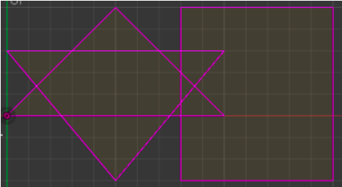

There are 12 unique regions. 11 formed by intersection of polygons and the last being the surrounding. So 5 samples from each continuous region gives 60 samples.

**Sample Input 1**

1

3

0 0

10 0

5 5

**Sample Output 1**

10

**Explanation 1**

One triangular region is formed. There are 2 unique regions by including the surrounding forest boundary. So 10 samples

Try these cases:

|  |  |
| --- | --- |
| **Input** | **Output** |
| 4  3  10000000 10000000  10000050 10000000  10000025 10000050  3  10000000 10000025  10000050 10000025  10000025 9999975  3  -10000000 -10000000  -10000050 -10000000  -10000025 -10000050  3  -10000000 -10000025  -10000050 -10000025  -10000025 -9999975 | 75 |
| 4  4  0 0  25 0  25 25  0 25  4  15 20  40 20  40 45  15 45  4  0 30  35 30  35 50  0 50  4  -5 10  30 10  30 40  -5 40 | 60 |
| 1  3  0 0  10 0  5 5 | 10 |
| 5  4  0 0  50 0  50 50  0 50  4  5 5  45 5  45 45  5 45  4  10 10  40 10  40 40  10 40  4  15 15  35 15  35 35  15 35  4  20 20  30 20  30 30  20 30 | 30 |
| 6  4  0 70  20 70  20 100  0 100  4  120 70  150 70  150 100  120 100  4  30 -10  110 -10  110 70  30 70  4  40 0  100 0  100 60  40 60  4  60 20  80 20  80 40  60 40  8  0 30  50 10  70 -30  90 10  140 30  90 50  70 100  50 50 | 105 |